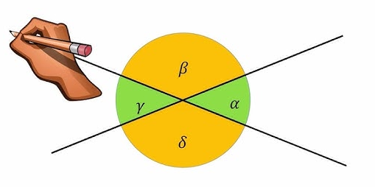 | 4.3 Winkelarten  4.4 Winkel-  Symmetrale | 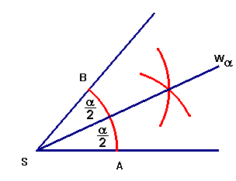

Lernziel | Typ 1 | Typ 2 | Typ 3
Winkelarten | 278, 279, 280acde, 281 | 282ac, 283 | 284ace, 285aeh
Winkelarten | 280b | 282b | 284bd, 285bcg
Winkelarten | 280e | 282d | 284f, 285df
Winkel-  Symmetrale | 286, 287a, 288acf | 289ab, 290b | 293, 295
Winkel-  Symmetrale | 287b, 288bd, | 289c, 290c | 294
Winkel-  Symmetrale | 288f | 289d, 290d | 292

4.3 Winkelarten

4.4 Winkel-
Symmetrale

Lernziel | Typ 1 | Typ 2 | Typ 3
Winkelarten | 278, 279, 280acde, 281 | 282ac, 283 | 284ace, 285aeh
Winkelarten | 280b | 282b | 284bd, 285bcg
Winkelarten | 280e | 282d | 284f, 285df
Winkel-  Symmetrale | 286, 287a, 288acf | 289ab, 290b | 293, 295
Winkel-  Symmetrale | 287b, 288bd, | 289c, 290c | 294
Winkel-  Symmetrale | 288f | 289d, 290d | 292

